NEW BIDDING CONTRACTOR
AGREEMENT

INCLUDING A RESTRICTIVE CONVENANT

By and between

AFFILIATED GROUNDS
MAINTENANCE GROUP INC.

A Pennsylvania Corporation
And
PUT NEW CONTRACTOR NAME HERE

THIS AGREEMENT is made this day of, , 2008 by and between Affiliated Grounds Maintenance Group Inc. , hereinafter referred to as “Contractor ” and, Put contractor company name here, hereinafter referred to as “Subcontractor”.

WHEREAS, Contractor is engaged in, among other things, the sale of a wide variety of grounds maintenance, parking lot maintenance, snow & ice control management, (hereinafter referred to as “the business”);and all related services.

WHEREAS, in the conduct and course of such business, Contractor subs work to individual subcontractors to perform a wide variety of functions, tasks and duties.

WHEREAS, Contractor has agreed to release information to new subcontractor for bidding purposes with the hope of forming a professional partnership for future work as contracts are awarded.

Subcontractor, agrees to bid work directly to contractor utilizing contractors bid forms, and will not solicit any open bidding directly or indirectly from any potential client whose information has been given to subcontractor by contractor

MADE AND EXECUTED at Erie, Pennsylvania on the date first above written by the undersigned parties intending to be legally bound hereby.

Contractor Affiliated Grounds Co. Name____________________________
Maintenance Group Inc. Address____________________________
5148 Peach St. # 311 ____________________________
Erie, Pa. 16509 City, State, Zip_____________________________

Signature 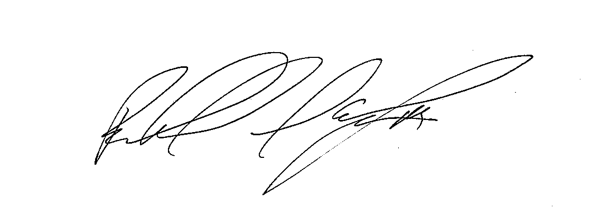 _________________________
Print RICHARD D. ARLINGTON III _________________________

Title National Business Manager _________________________

